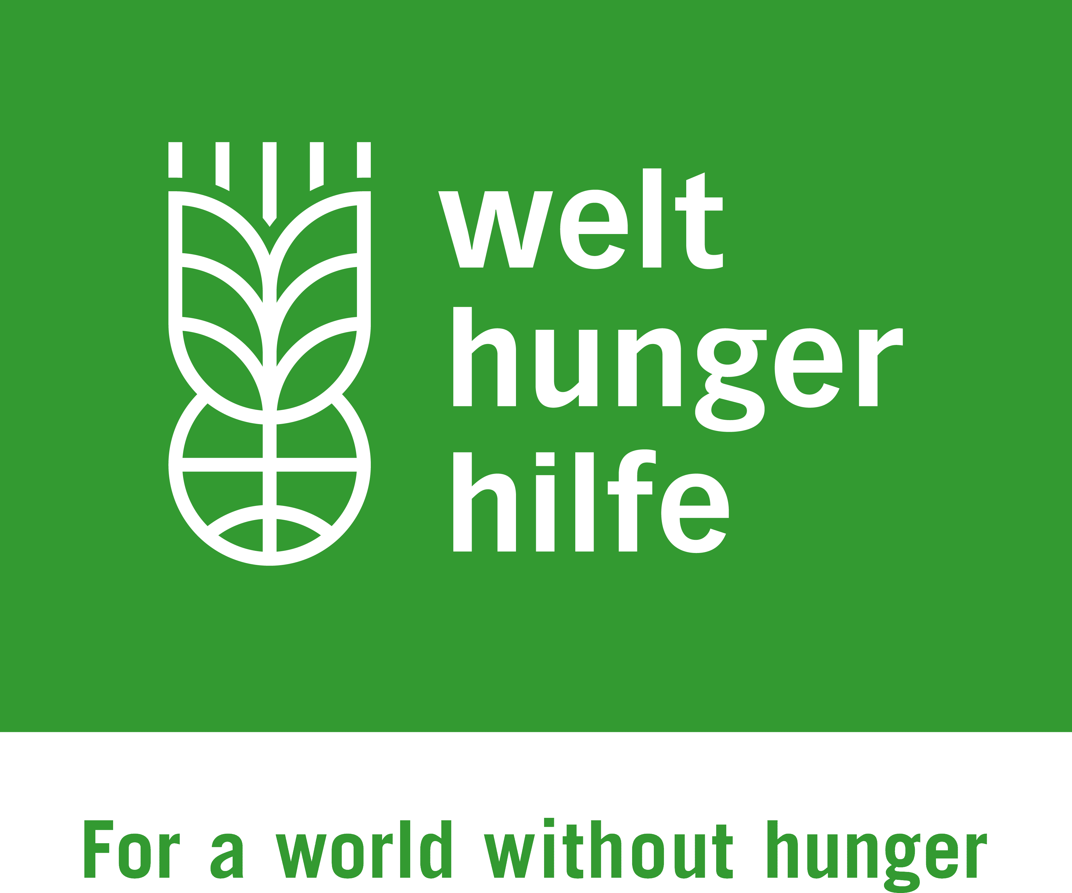
Annex 1

Welthungerhilfe Supplier Qualification Form
Page 1 / 3

- We want some information about your company

Company Name
Legal Form
Founded (Year)
Established in (Country)
Bank Details (Account Holder, Bank Name, IBAN, BIC, Swift, Currency)

VAT-Registration Number

Physical Address

Name of Chief Executive Officer (CEO)
Place and Date of Birth of CEO
Name of Owner

Place and Date of Birth of Owner (if individual)
Website
Sales & Marketing Contact

Range of Services provided by the Company (Company Portfolio)
For internal use of WHH only

Welthungerhilfe Supplier Qualification Form
Page 2 / 3

2. Policy Statement of Welthungerhilfe

- Welthungerhilfe supports the goals of the UN Global Compact
The UN Global Compact is a strategic policy initiative for businesses that are committed to aligning their operations and strategies with ten universally accepted principles in the areas of human rights, labour, environment and anti-corruption.
Human Rights
- Principle 1: Businesses should support and respect the protection of internationally proclaimed human rights; and
- Principle 2: make sure that they are not complicit in human rights abuses.
Labour
- Principle 3: Businesses should uphold the freedom of association and the effective recognition of the right to collective bargaining;
- Principle 4: the elimination of all forms of forced and compulsory labour;
- Principle 5: the effective abolition of child labour; and
- Principle 6: the elimination of discrimination in respect of employment and occupation.
Environment
- Principle 7: Businesses should support a precautionary approach to environmental challenges;
- Principle 8: undertake initiatives to promote greater environmental responsibility; and
- Principle 9: encourage the development and diffusion of environmentally friendly technologies.
Anti-Corruption
- Principle 10: Businesses should work against corruption in all its forms, including extortion and bribery.
The Global Compact is global and local; private and public; voluntary yet accountable.
Further information is available on this website in different languages : https://www.unglobalcompact.org

- Welthungerhilfe (WHH) renounces all forms of terrorism and money laundering
Welthungerhilfe renounces all forms of terrorism and will never knowingly support, tolerate or encourage terrorism or the activities of those who embrace terrorism or money laundering. Consistent with numerous United Nations Security Council resolutions, including S/RES/1269(1999), S/RES 1368(2001) and S/RES1373(2001) and the European Union, Welthungerhilfe is firmly committed to the international fight against terrorism and in particular against the financing of terrorism. It is the policy of Welthungerhilfe to seek to ensure that none of its and its donor funds are used, directly or indirectly, to provide support to individuals or entities associated with terrorism or money laundering. Therefore, Welthungerhilfe will match their suppliers and Service providers against the Sanctions lists on a regular basis. By submitting an offer, suppliers and service providers agree to this.

Welthungerhilfe Supplier Qualification Form
Page 3 / 3

3. Supplier Declaration

We, _____________________________________ (name of company) hereby declare that

- we are not in bankruptcy proceedings, judicial insolvency proceedings or in liquidation, that we have not ceased our commercial activities and are not in a comparable situation by virtue of similar proceedings referred to in the national legal provisions,

- we have not received a sanction by legally binding judgment for reasons which bring into doubt our professional reliability,

- we comply with our duty to pay social insurance contributions, taxes or other levies in accordance with the legal provisions of the state in which we have our office, the state of the consignee, or the state where the contract is performed. We assure that we will comply with the legislation applicable and common standards in terms of wages, social legislation and occupational safety and health.

- we have not received a legally binding sentence due to fraud, corruption, participation in a criminal association, or another act directed against the financial interests of the International Humanitarian Aid Community,

- no serious breaches of contract due to non-performance of our contractual obligations have been ascertained in connection with another contract or a contract awarded from the International Humanitarian Aid Community,

- we are providing you with all the information required in connection with participation in a tender,

- in respect of contracts which are ultimately paid for out of European Community funds, no one has accused us of breach of contract due to gross violation of our contractual obligations,

- we have not been excluded as a contract partner by the European Community due to ethical issues,

- we assure the European Commission, the European Anti-Corruption Bureau and the auditors of the European Community reasonable access on demand to our business and accounting documents for the purpose of checks and audits,

- we respect basic social rights and condemn child labor,

- we are informed that Welthungerhilfe will conduct a check to ensure that partners/suppliers do not appear on official sanctions lists of UN and the European Union.

__________________________________________________________________________
Date, Company Name, Signature of Owner of CEO, Name in Block letters, Stamp

