OUTLINE1 FOR EVALUATION PROJECT REPORTS

(Manual “Evaluation Management”, Step 9: Write and approve final report)

Preliminary notes on writing the final report
- The final report should be clear and concise with about 25–35 pages main text, including the executive summary but excluding the front page, table of contents, lists of tables and abbreviations, and annexes. The evaluation report must contain a max.
5-page executive summary and several mandatory annexes.
- The evaluator(s) have to use the Welthungerhilfe template “Outline for evaluation reports” and should consider the explanations given there in the final report. They have to insert sub-sections as appropriate to structure the document – especially in section 3 “Findings, conclusions (and recommendations)”. The evaluation matrix could guide the evaluator(s) when inserting sub-sections into the standard reporting outline.
- The final report is to be submitted electronically, both in a PDF and in an editable format
(preferably Word).
- The evaluator(s) are supposed to consult the standard checklist “Evaluation reporting quality” to make sure the report fully complies with Welthungerhilfe evaluation requirements.

Tips:
- Repetitions should be avoided, make use of cross-references. The report has to be written in a way that readers who are not familiar with the project and the sector can understand its contents. Therefore, avoid Buzzwords, and use clear, specific and technically appropriate language.
- The report should be as engaging and readable as possible. Think about ways to ensure this, i.e. use subtitles, bold font, incorporate quotes, pictures and visualisations
- Definitions and terms embedded in results chains are not used in a uniform manner by organisations working in the field of development cooperation. For this reason, the most important terms for Welthungerhilfe in the results chain (diagram 1) are presented in the following diagram. (This diagram has been taken from Welthungerhilfe’s 2008 guide- lines “Outcome and Impact Orientation”.)
Diagram 1: Schematic overview of the results chain
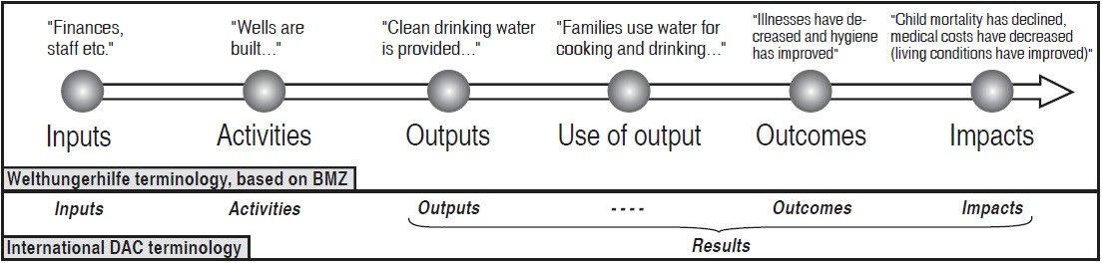

1 In accordance with ALNAP Guide to Evaluation Humanitarian Assistance (2017), p. 332ff.

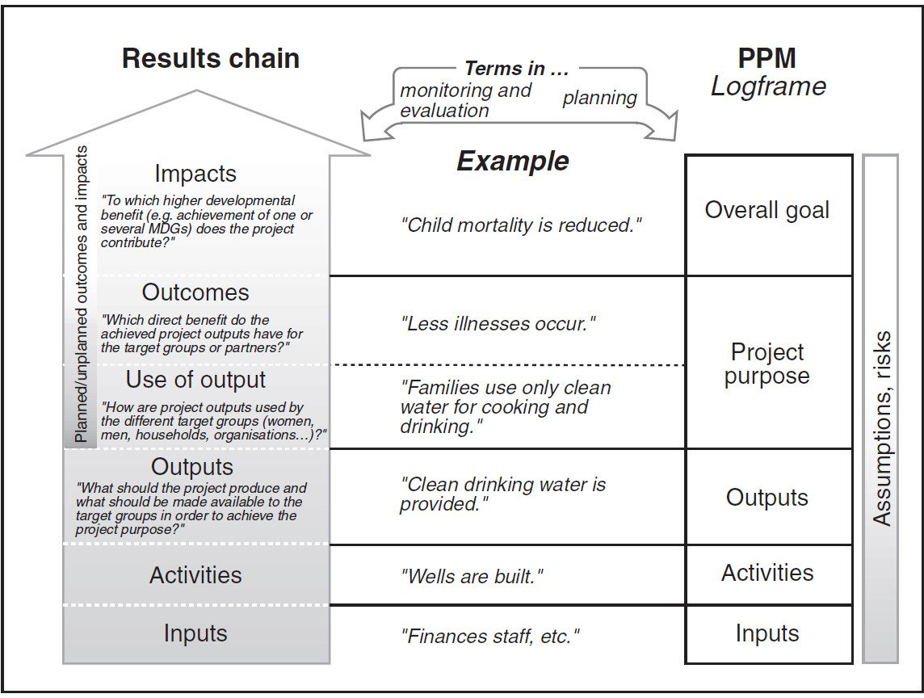
Diagram 2: Different terms in the result chain concept and project planning (based on the DAC Glossary)

Outline- Section | Pages | Content | Tips! / Remember!
Cover page and opening pages | 2–3 | - type of report (evaluation report)  - the type of the evaluation (external midterm or external final)  - the title of the project that is evaluated, project number, country, donor  - name of the evaluator(s)/company, date  - Welthungerhilfe and the partner organisation as the commissioning parties  - the logos of Welthungerhilfe, the relevant donors and the partner organisations  - a photo representing a project activity for a good visual impression of the report  - table of contents  - list of figures and tables  - abbreviations and acronyms | Protection of your personal data: Please be aware that we publish the evaluation report on our publicly avai-lable website www.welthungerhilfe.org. You agree to the publication of the personal data you provide in this section.
0. Executive summary | 3–5 | The executive summary is an independent and self- explanatory document and includes:  - overview of the project being evaluated (project purpose, main activities, target group, intervention area, implementing structure)  - evaluation objectives and intended users/audience  - evaluation design and methods  - most important findings and conclusions, following the sequence in which these are presented in the main report  - main recommendations | Tip: As most of the evaluation report’s readers might, or are even most likely to, only read the executive summary, special attention and time should be devoted to this stand-alone section of the evalua- tion report. Especially the recommendations should be highlighted, for example in a table stat- ing their priority level.  Tip: It is recommendable to allow the evaluator(s) to omit the executive summary in the draft version of the report, as adaptions might follow the feedback process on the core body of the report.
1. Introduction | 1–2 | - Scope and purpose of the evaluation, intended audience, team composition  - The overarching evaluation questions  - Were there any changes to the evaluation questions proposed in the ToR?
Outline- Section | Pages | Content | Tips! / Remember!
2. Description of project and context | 2–3 | - Overview of the project, using the table providing basic project data (see the table below)  - Project summary of the intervention area(s), e.g. project purpose and main activities, project participants | Please use the following table for overview of the project:
3. Methodological approach | 2–5 | - Description of the evaluation design and main methods used, their appropriateness and why they were chosen (also in light of gender-responsiveness, triangulation, use of existing monitoring or complaints-response-mechanism data), as well as their limitations  - Description of sampling / rationale and selection process, as well as criteria for data sources  - If you have evaluated against a DAC criterion or logframe or any other type of framework, you should make refer- ence to it here and include it an annex  - Level and type of participation of the project partici- pants  - Key constraints to carrying out the evaluation (e.g. lack of time, constrained access to project participants lack baseline / monitoring data), and their effect  - Any biases in the evaluation process or evaluation team and how these were mitigated | Remember: Should you have chosen only some of the OECD/DAC criteria as reference framework for your evaluation, make sure you justify your selection and explain why you decided to omit the others (see ToR section). Should you have opted to organise your evaluation questions in an- other way / according to other reference framework, please specify.
Overall goal/ indicator
Project purpose/ indicators
Target group and final beneficiaries
Project phase duration: |  | Reporting period:
Total eligible cost of the action: | Amount from the contracting authority: | Amount from project holder: | Other funds:
Co-financer:

Outline- Section | Pages | Content | Tips! / Remember!
4. Findings and Conclusions | 8–15 | - Organised by evaluation criteria (OECD/DAC), by evaluation questions or other framework appropriate to the evaluation and its intended users.  - presents findings and respective evidence, con-  clusions, i.e the evaluators justified appraisal of (aspects of) the project. | Tip: Section 3 and 4 can be combined if deemed helpful  Tip: Think about appropriate sub-chapters and present you an outline as a deliverable.  (See: ToR Development)  Tip: Present evidence in the report. Hence, include quotes from beneficiaries and use photographs, tables and charts to illustrate and summarise key points (making sure to gain consent and respect confidentiality as appropriate)  Tip: Some helpful definitions:  - Finding:  A finding is factual statement based on evidence  - Conclusion:  A conclusion is an inductive statement based on one or more findings  - Recommendation:  A recommendation is a course of action the eval- uator(s) suggest(s) as a way to address one or more conclusions  There should be a logical flow between findings, conclusions and recommendations
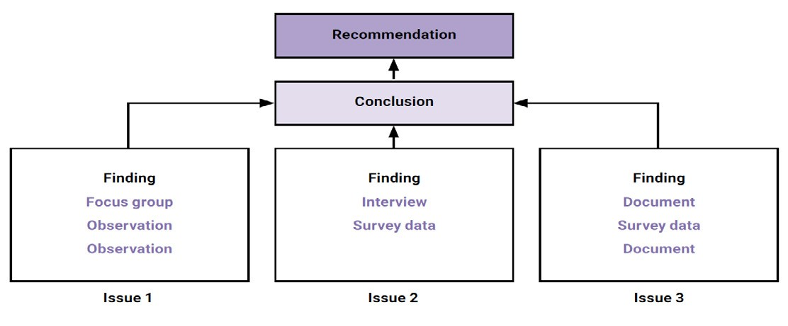
Outline- Section | Pages | Content | Tips! / Remember!
5. Recommen- dations | 2–5 | Have to be:  - Clearly linked to findings and conclusions  - Clear, relevant, reflecting any constraints to follow-up  - Presented in priority order, with a timeframe for implementation, suggesting where responsibility for follow-up should lie  - Limited in number (5–15 recommendations)  Note: Recommendations have to be presented in the recommendation chapter as well as in the tem- plate “Standard management response matrix” that is a mandatory annex of the evaluation re- port. | Tip: If it seems difficult to reduce the number of recommendations, it could help to try to cluster recommendations according to their focus.  Tip: You may want to present (different) options as recommendations instead of direct advice.  Remember: It might be worth considering either to make key stakeholders develop recommendations, i.e. in a facilitated session or to have their feedback on draft recommendations through a consultative process (see Step 8: Debriefing).  Tip: Evaluation recommendations are clear, relevant and implementable if they are:  - Specific – it must be clear exactly what is being recommended.  - Actionable – should state as much as possible actions to implement the recommendation.  - Directed – the person or entity responsible for implementing the recommendation should be identified; responsibility may be further clari- fied in a management response to the report.  - Time-bound – a timetable for implementing the recommendations should be given wherever possible.  - Prioritised – it should be clear which recommendations are of primary concern and which are secondary.  - Economical – the recommended actions should clearly deliver benefits in proportion to their costs.

Outline- Section | Pages | Content | Tips! / Remember!
Annexes |  | - Annex 1: Terms of reference (mandatory)  - Annex 2: Evaluation matrix (mandatory)  - Annex 3: Data-collection instruments, incl. information on informed consent handling (mandatory)  - Annex 4: Project planning matrix / logframe (mandatory)  - Annex 5: Travel and work schedule (mandatory)  - Annex 6: Debriefing notes (mandatory)  - Annex 7: Sources (e.g. bibliography, people interviewed) (mandatory)  - Annex 8: Management response matrix (mandatory)  - Annex 9 : Standard project assessment according to OECD/ DAC criteria (mandatory)  - Maps (optional)  - Photos, incl. credits, informed consent handling (optional)  - Others (as required) | Tip: If you intend to attach various pictures consider separating the annexes from the report  Tip: You may attach the Inception Report to give more details on the methods, such as data- collection instruments

